Grade 9/10

3.3.2 Spells accurately in final draft.
- Uses spelling words and patterns from the previous grades.
- Uses multiple strategies to spell.
Examples:
  - homophones (e.g., council and counsel, stationary and stationery)
  - affixes (e.g., -cian, -ness)
  - roots (e.g., anthropology, philosophy)
  - foreign spellings (e.g., alumna/alumnae/alumnus, medium/media, datum/data)
  - words from other languages (e.g., bourgeois, kindergarten, espresso, boutique, coyote)
  - frequently misspelled words (e.g., perceive, congratulations, success)
- Uses resources to correct own spelling.

3.3.3 Applies capitalization rules.
- Uses capitalization rules from previous grades.
- Uses resources to check capitalization.

3.3.4 Applies punctuation rules.
- Uses punctuation rules from previous grades.
- Uses commas to set off nonrestrictive clauses (e.g., The gym, which was built last year, is used every day.).
- Uses brackets around an editorial correction or to set of added words.
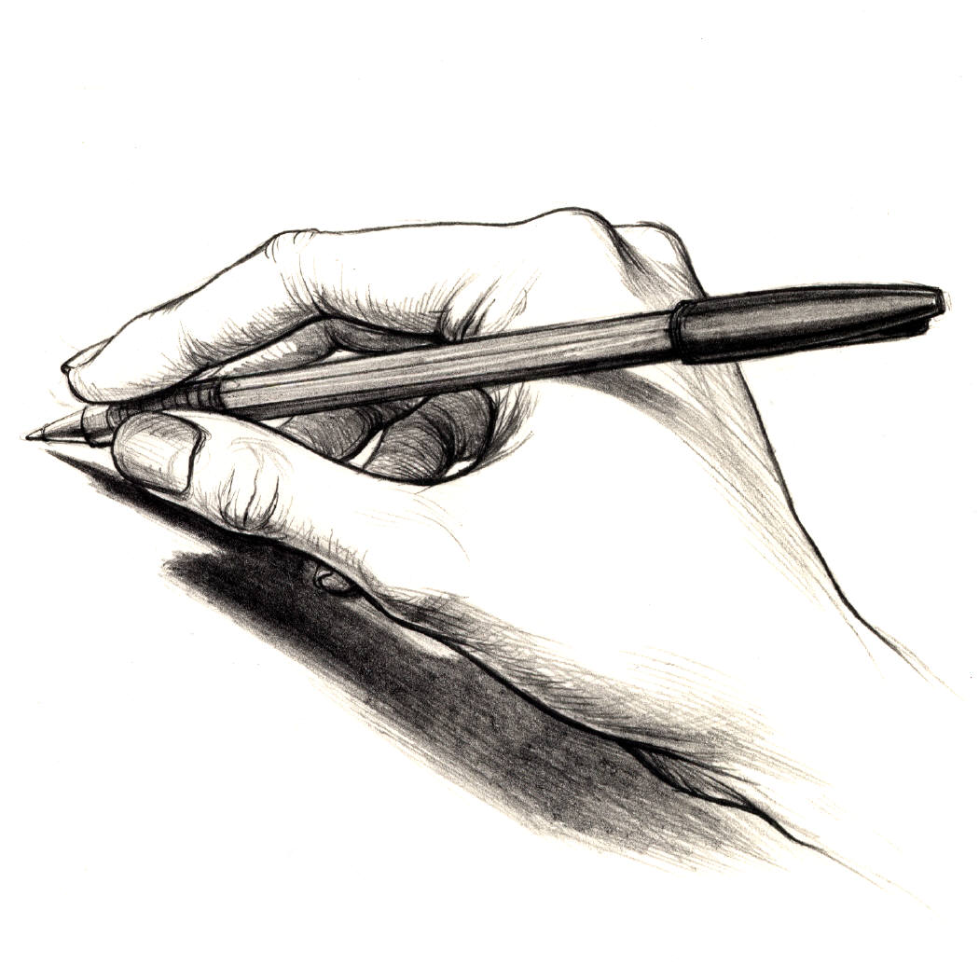
- Uses the em dash ( ) to indicate emphasis or sudden break, to set off an introductory series, or to show interrupted speech.
- Uses appropriate punctuation when writing in other languages (e.g., René).
- Uses resources to check punctuation.

3.3.5 Applies usage rules.
- Applies usage rules from previous grades.
- Avoids dangling modifiers (e.g., After I stood in line for hours, I discovered the tickets were sold out. Incorrect: After standing in line for hours, the tickets were sold out. The second sentence makes it appear that the tickets were in line.).
- Uses who vs. whom correctly.
- Uses that vs. which and that vs. who correctly.
- Uses either or and neither nor correctly.
- Uses many commonly confused words correctly (e.g., accept vs. except or can vs. may).
- Uses active voice except when passive voice is appropriate (e.g., active voice: They saw it. vs. passive voice: It was seen by them.).
- Uses parallel construction in clauses.
- parallel: The coach told the players they should get plenty of sleep, they should eat well, and they should do some warm-up exercises.
- not parallel: The coach told the players they should get plenty of sleep, that they should eat well and to do some warm-up exercises.
- Uses resources to check usage.

3.3.6 Uses complete sentences in writing.
- May use fragments in dialogue as appropriate.

3.3.7 Applies paragraph conventions.
- Uses paragraph conventions (e.g., designate by indentation or block format, skipping lines between paragraphs).
- Uses textual markers (e.g., page numbers, footnotes, space for pictures).

3.3.8 Applies conventional forms for citations.
- Cites sources according to prescribed format (e.g., MLA, APA, Turabian).

